Data Analytics Internship
Level 2 – Task 2

1. Objective
The objective of this project is to apply the K-Means clustering algorithm to the Iris dataset in order to group flowers based on their physical characteristics. This project demonstrates how unsupervised machine learning can identify natural patterns in data without using predefined class labels.

2. Dataset Description
The Iris dataset is one of the most widely used datasets for clustering and classification tasks. It contains measurements of three different Iris flower species.
Dataset Information
- Total Records: 150
- Total Features: 4
- Features:
  - Sepal Length
  - Sepal Width
  - Petal Length
  - Petal Width
- Species:
  - Setosa
  - Versicolor
  - Virginica
Before training the model, the dataset was checked for missing values and duplicate records. The feature values were standardized to ensure equal contribution during clustering.

3. Methodology
The following steps were performed during the project:
- Imported the required Python libraries.
- Loaded the Iris dataset.
- Examined the dataset structure and summary statistics.
- Checked for missing values and duplicate records.
- Standardized the numerical features using StandardScaler.
- Applied the Elbow Method to determine the optimal number of clusters.
- Trained the K-Means clustering model with 3 clusters.
- Reduced the feature dimensions using Principal Component Analysis (PCA) for visualization.
- Visualized the clustered data.
- Generated a cluster-wise summary.

4. Elbow Method Analysis
The Elbow Method was used to identify the most appropriate number of clusters by plotting inertia against the number of clusters.
Observation
The graph shows a significant decrease in inertia from 1 to 3 clusters, after which the reduction becomes more gradual. This indicates that three clusters provide a good balance between model simplicity and clustering quality. Therefore, K = 3 was selected for the final model.
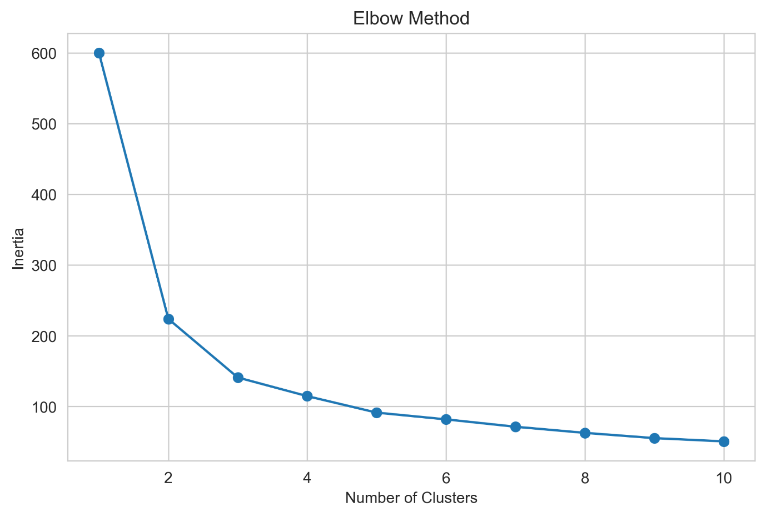

5. Cluster Visualization
Principal Component Analysis (PCA) was used to project the four-dimensional feature space into two dimensions for visualization.
Observation
The visualization shows three distinct groups of flowers.
- One cluster is clearly separated from the others, representing flowers with unique feature values.
- The remaining two clusters are closer together, indicating that their characteristics are more similar.
- Overall, the clustering algorithm successfully identified meaningful patterns within the dataset.
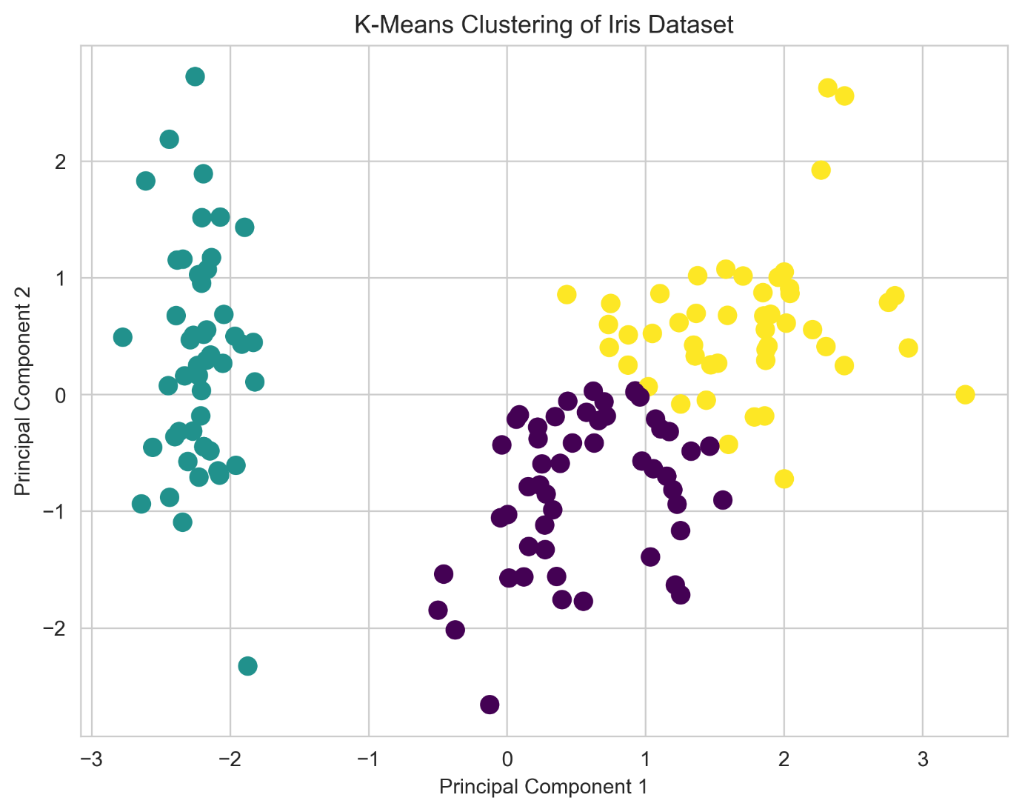

6. Cluster Summary
The average feature values for each species are summarized below:
Species | Sepal Length | Sepal Width | Petal Length | Petal Width
Setosa | 5.006 | 3.418 | 1.464 | 0.244
Versicolor | 5.936 | 2.770 | 4.260 | 1.326
Virginica | 6.588 | 2.974 | 5.552 | 2.026
Interpretation
- Setosa flowers have the smallest petals and are easily distinguishable.
- Versicolor exhibits intermediate measurements.
- Virginica generally has the largest petals and longer sepals.
- Petal length and petal width contribute significantly to separating the flower groups.

7. Tools and Technologies Used
- Python
- Pandas
- NumPy
- Matplotlib
- Seaborn
- Scikit-learn
- PCA (Principal Component Analysis)
- Jupyter Notebook
- VS Code

8. Conclusion
The K-Means clustering algorithm was successfully implemented on the Iris dataset. Using the Elbow Method, the optimal number of clusters was determined to be three. PCA visualization demonstrated that the algorithm effectively grouped flowers with similar characteristics. The project highlights how unsupervised learning techniques can uncover meaningful structures in data without relying on predefined labels.

